1. Install angular js 1.2.0 from eclipse marketplace. Automatically tern also will get installed.

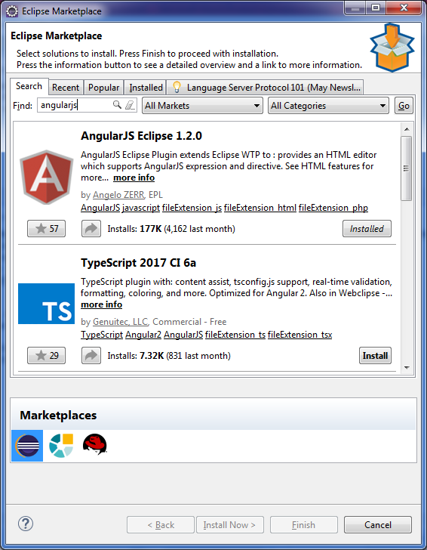

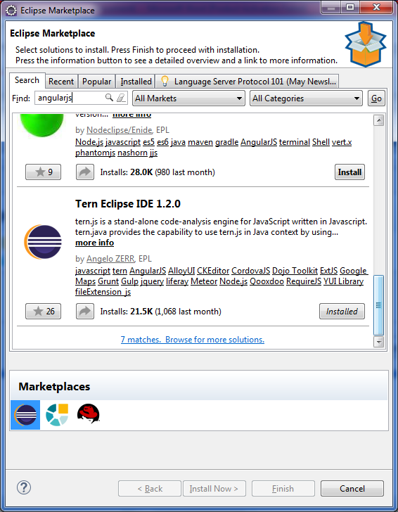

1. Install node js in your local. Make sure, it is the current version (even though Embed node.js is installed in your above step)

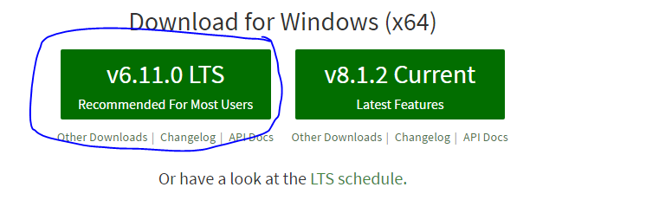

1. Install protractor and webdriver manager using the npm commands in cmd prompt
   1. npm install –g protractor
   2. npm install –g webdriver-manager
   3. do an update post installation for manager, webdriver-manager update

**Note:**

* Check version of protractor as follows,
  + Protractor --version
  + Webdriver-manager –version
* If proxy is available
  + Check for proxy, npm get config
  + If proxy is null in the above step, npm set config proxy http:<(hostname_ip) or (domain address.com)>/port
* Then proceed with the 3rd step

1. Create a java script project as follows,

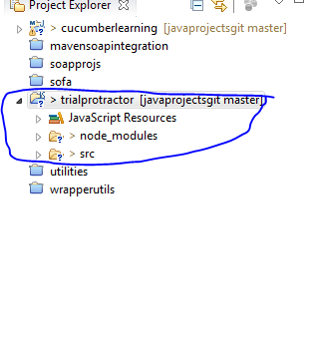

1. Copy paste “node_modules” folder containing “protractor” folder inside npm

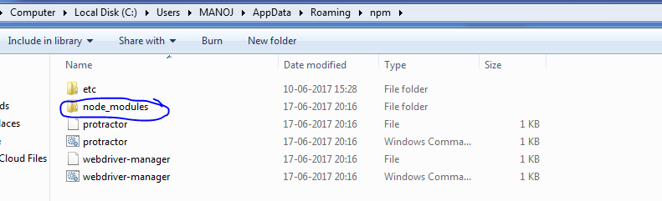

Note: check the below folders before pasting

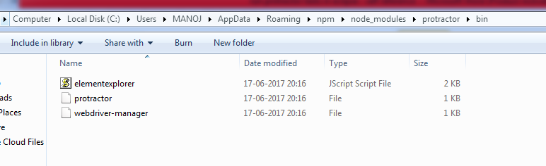

-----

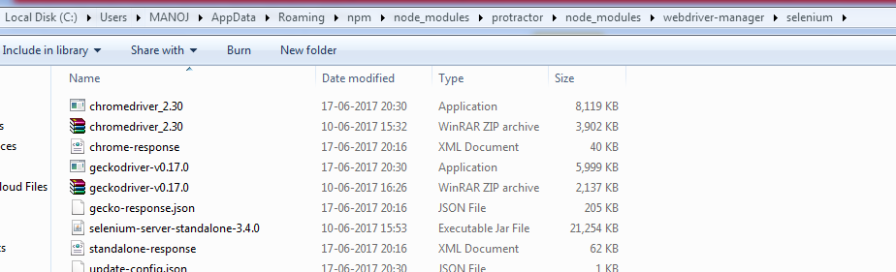

-----

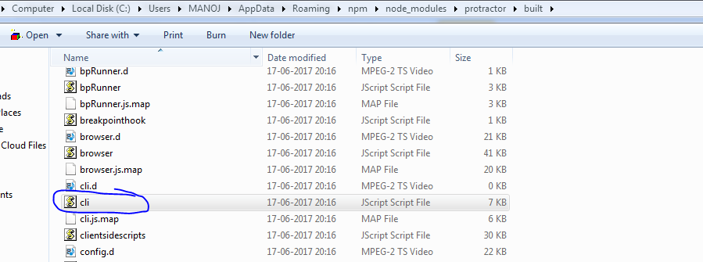

1. Once eclipse angular js is installed, go to window 🡪 preferences 🡪 angularjs 🡪 protractor and set the following

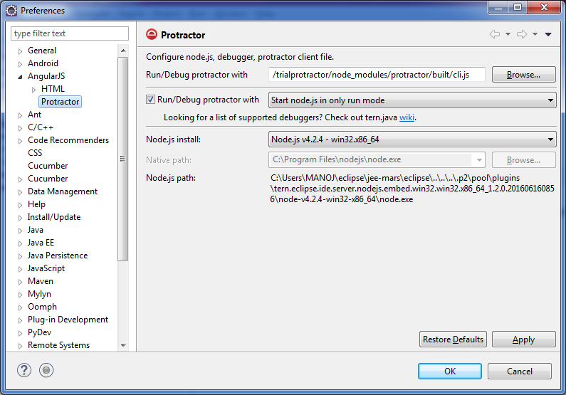

1. Now convert the javascript project into tern project as follows,

Right click on project folder 🡪 Configure 🡪 Convert to Tern Project

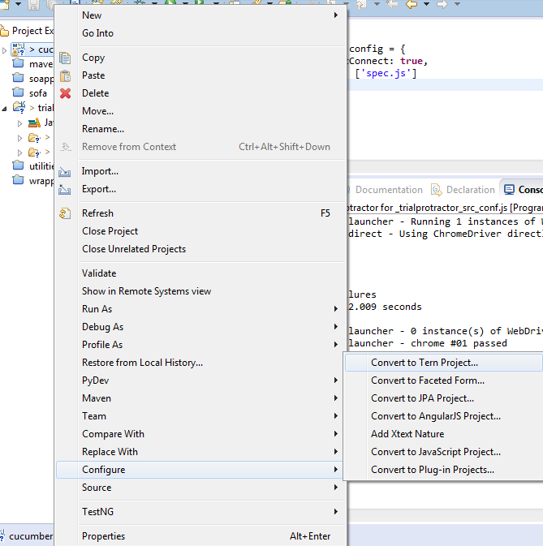

Choose **Jasmine** and **protractor** from the below popup

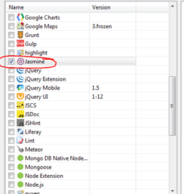 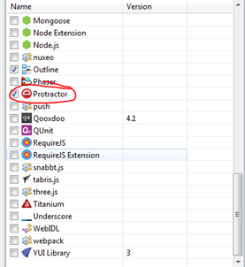

**Note:**

Also, check “Jasmin” and “protractor” under Preferences 🡪 Javascript 🡪 Tern 🡪 Development 🡪 Repositories (this step can be done for an already “converted to Tern project”)

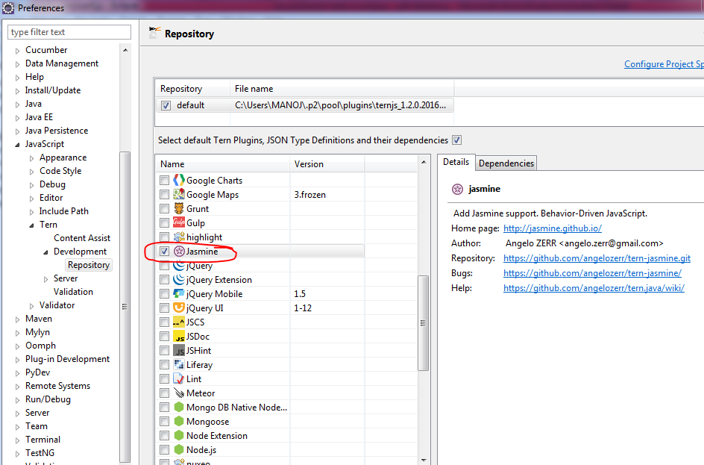

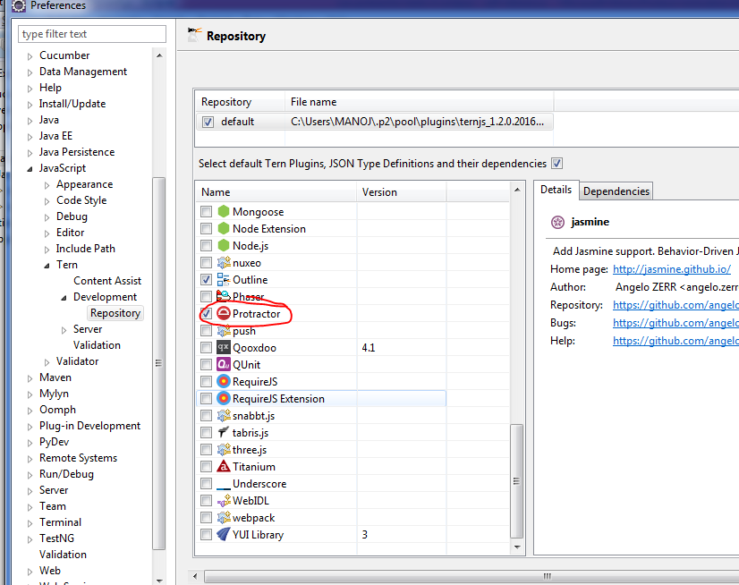

1. Now set the run configurations for your project as follows and run the config.js file successfully.

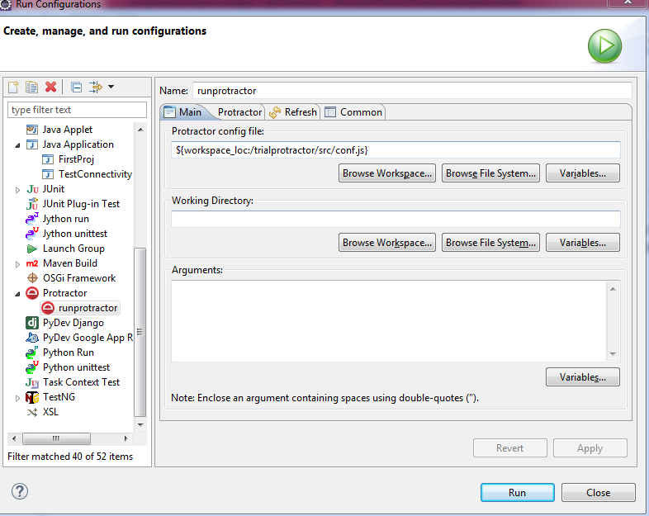

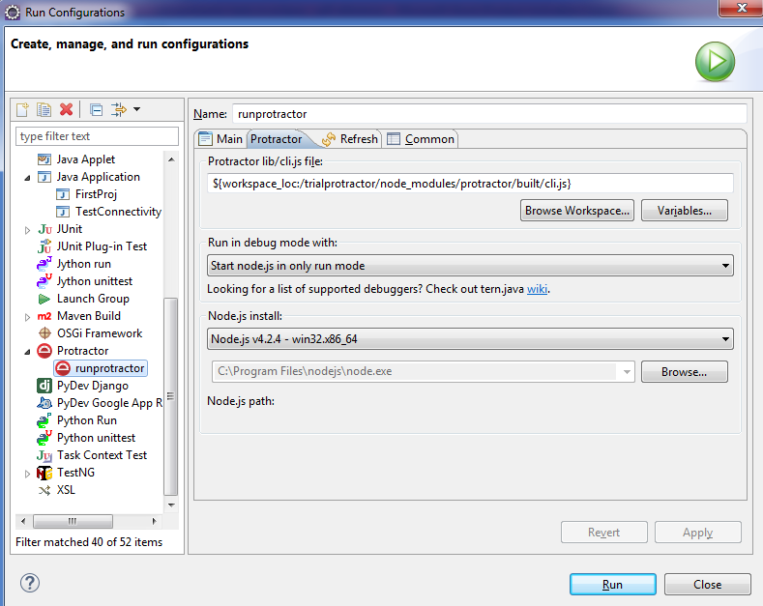

Console:

[20:33:30] I/launcher - Running 1 instances of WebDriver

[20:33:30] I/direct - Using ChromeDriver directly...

Started

_[32m._[0m

1 spec, 0 failures

Finished in 12.009 seconds

[20:33:53] I/launcher - 0 instance(s) of WebDriver still running

[20:33:53] I/launcher - chrome #01 passed

**Issues faced:**

 